CMDB SNOW SET-UP

On the search bar on the right hand top corner in SNOW, search for “Computers”

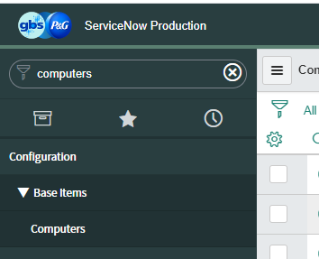

Select “Computers” from the drop down.

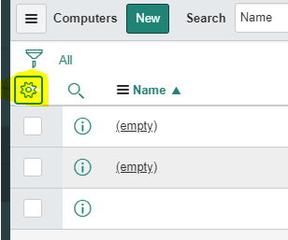

Click on the wheel at the top left hand of your screen.

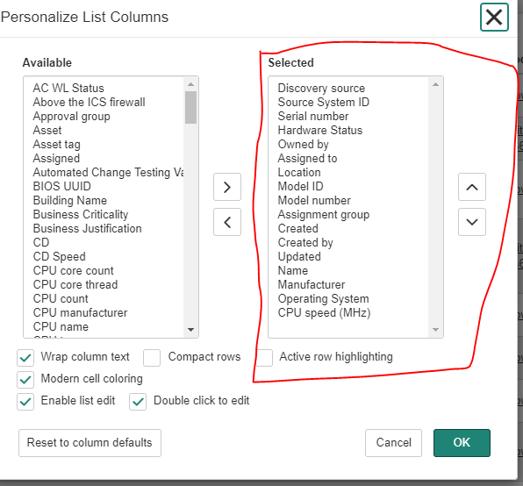

Select your filter to match the above. Click “OK” when done.

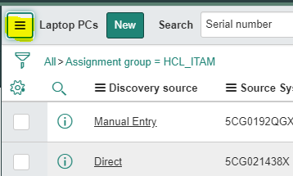

Click on the above.

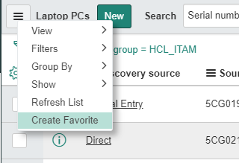

Select “Create Favorite”

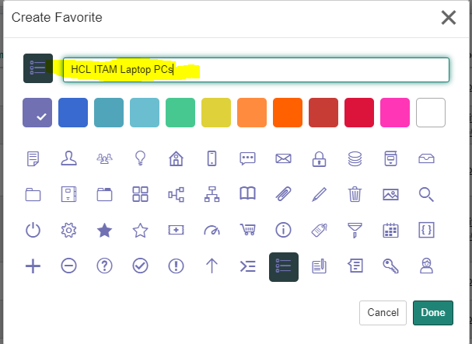

Give it a name and click on “Done”.

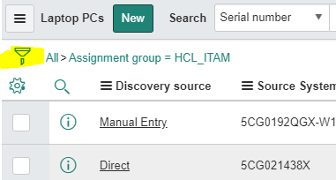

Click on the filter icon

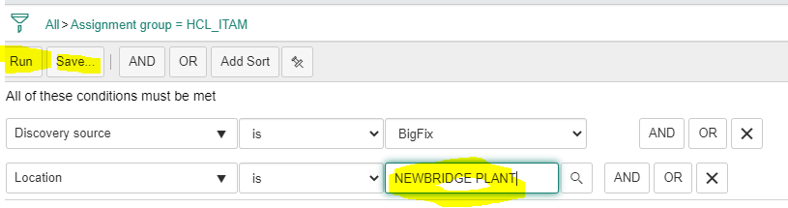

Set the conditions above with your location name, Save it. Then run it.

This will show in SNOW under favorites.

REPEAT THE SAME PROCESS FOR DESKTOPS.